# Jadon Argo

CSD-325 – Module 1 Assignment

"100 Bottles of Beer on the Wall" Flowchart

Date: [6/3/2025]

## Flowchart for Beer Countdown Program

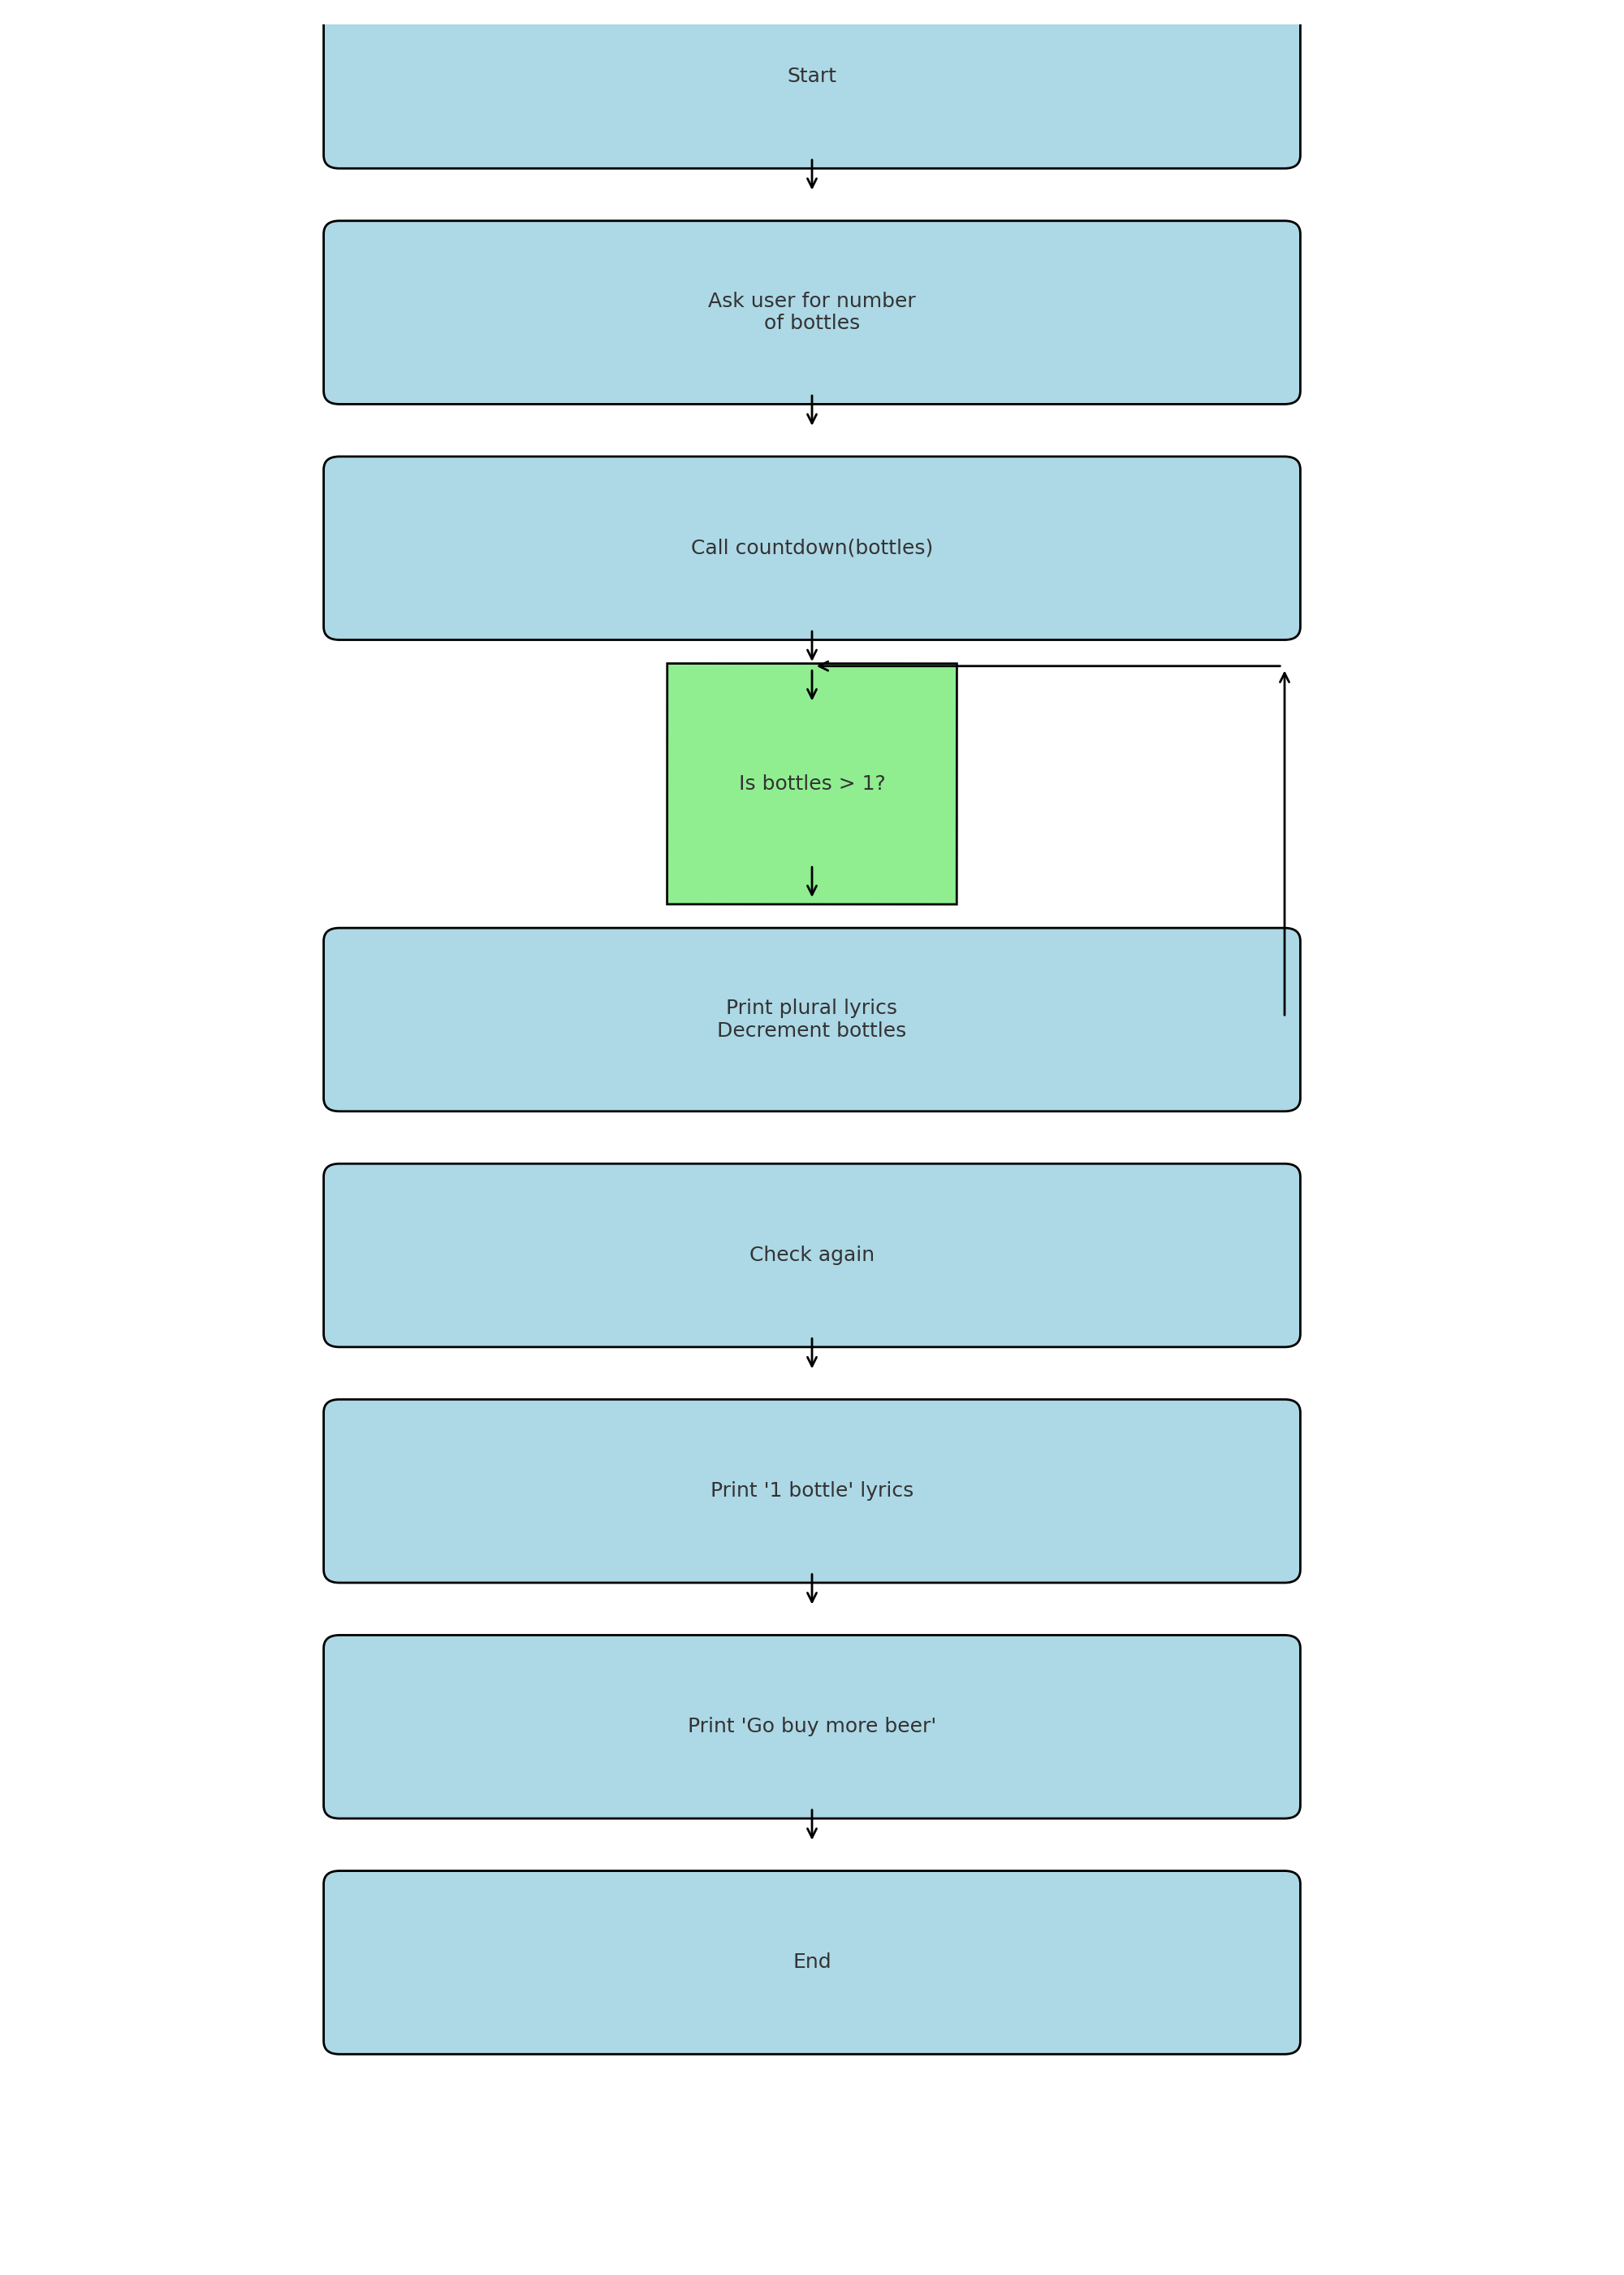

The program:

1. Accepts user input for number of bottles.

2. Uses a function to manage the countdown loop.

3. Changes wording for 1 bottle.

4. Ends with a message to buy more beer.

See accompanying `.py` file: `bottles.py`.